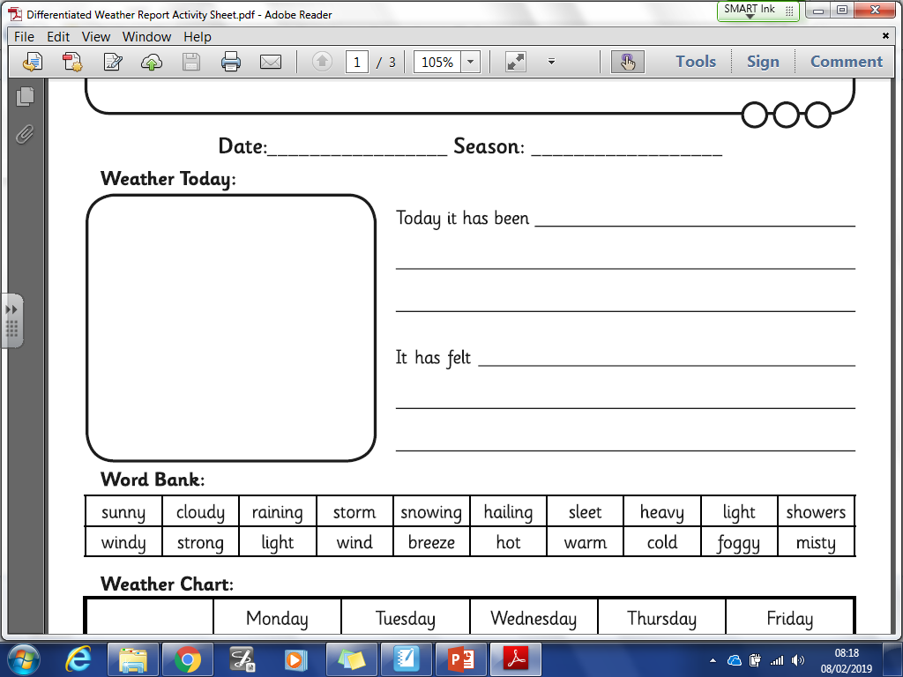

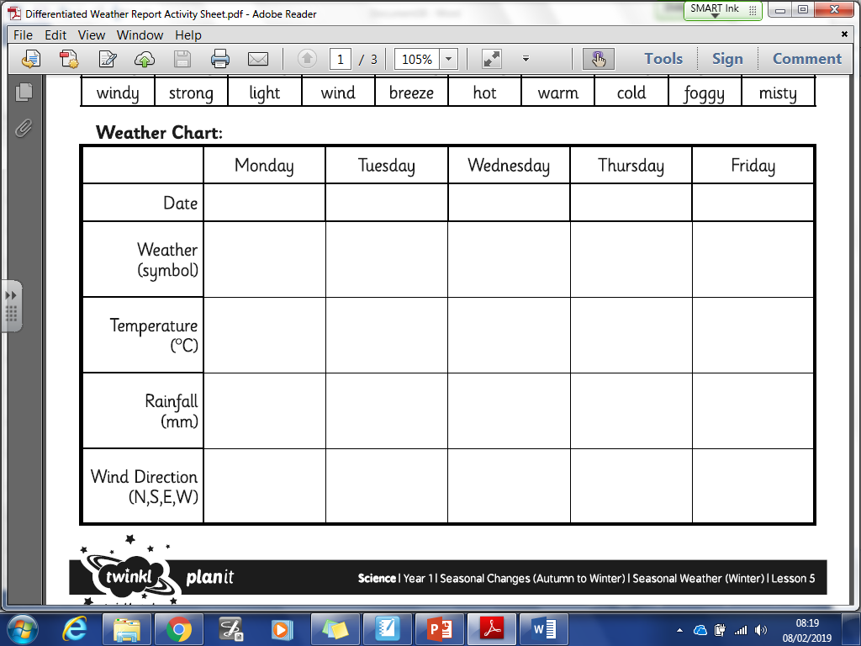

When I go to bed it is:

______________________________________________

______________________________________________

______________________________________________

When I woke up it was:

______________________________________________

______________________________________________

______________________________________________