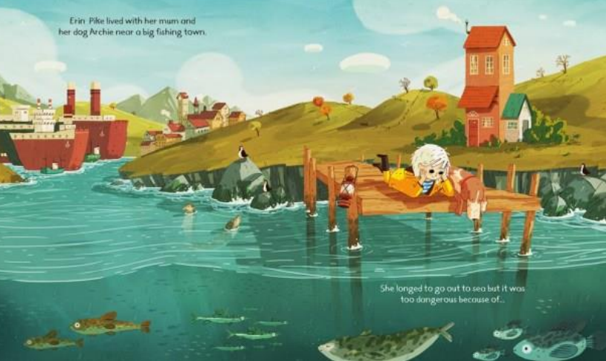Inference questions

1. Where do you think this place is? Write down some words that describe it.
2. Who do you think the girl is and what could she be thinking about?
3. Read the words in the picture – What can we learn about Erin’s life?
4. How would you describe Erin’s character? Why?
5. Why do you think Erin ‘longed to go out to sea’?
6. The text says ‘it was too dangerous because of…’ – what do you predict this danger could be?
7. Who do you think has told her it’s too dangerous? Why?