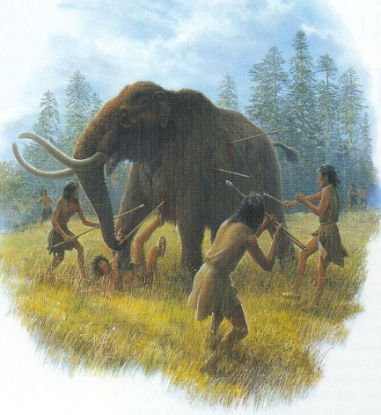

**L****.O Hunting for food during the middle Stone Age**

Climate change during the Stone Age caused animal life in Britain to go through lots of changes. During the Ice Ages, Britain was covered by ice and snow. Herds of mammoths, reindeer and woolly rhinoceroses roamed across the snow and forests and brown bears sheltered in caves.

Find useful information on the BBC Bitesize website

Watch the 1st video [https://www.bbc.co.uk/bitesize/topics/z82hsbk/articles/z34djxs (4](https://www.bbc.co.uk/bitesize/topics/z82hsbk/articles/z34djxs%20%20%20%20(4) minutes)

**How did Stone Age hunter-gatherers live?**

Here is useful information from that website

Stone Age hunter-gatherers had to **catch** or **find** everything they ate. They moved from place to place in search of food.

Early Stone Age people hunted with **sharpened sticks**. It took many hundreds of years later before they used **bows and arrows** and **spears** tipped with flint or bone. People gathered nuts and fruits and dug up roots. They went fishing using **nets** and **harpoons**.

Stone Age people cut up their food with sharpened stones and **cooked it on a fire**. They used **animal skins** to make clothes and shelters. After a good day’s hunting people could feast on meat. But the next day they had to start finding food again!

In the early Stone Age, people made simple hand-axes out of stones. They made hammers from bones or antlers and they sharpened sticks to use as hunting spears.

Watch the 2nd video <https://www.bbc.co.uk/teach/class-clips-video/story-of-britain-middle-stone-age-animation/zvkg92p> (7minutes)

Now imagine feeling hungry when you wake up in the morning in your Stone Age cave, or more likely a tent made of animal skins.

1. Research what sort of animals lived in Britain during the Stone Age, then describe how your family will attempt to hunt food that day. Will you join forces with fellow humans living nearby? What strategies will your family use to hunt? Could you act as an animal spotter?
2. Now draw a picture of you and your family hunting animals for food.

**Caption** your drawing (in other words describe briefly what is happening in your picture).

If your parents have time to help you there is further information on this website

<https://www.theclassroom.com/what-kind-of-animals-did-the-hunter-gatherers-hunt-12084396.html>

but sadly it is written in language for adults, so maybe your grown-ups can help you understand some of the difficult words.