

Lunsford Primary School – Home Learning
Monday 11th January – Friday 15th January 2020
Year 3 – Lion Class
Weekly Maths Tasks | Reading tasks
This week’s maths is still looking at multiplication and division. Watch the video and then complete the worksheet. The final few questions on the work sheet are difficult so don’t be discouraged if you find them hard.  Monday  Spr3.2.2 - Multiply 2-digits by 1-digit (2) on Vimeo  Multiply 2 digits by 1 digit (2)  15 mins of TTRockstars  Tuesday  Spr3.2.3 - Divide 2-digits by 1 digit (1) on Vimeo  Divide 2 digits by 1 digit (1)  15 mins of TTRockstars  Wednesday  Spr3.2.4 - Divide 2-digits by 1 digit (2) on Vimeo  Divide 2 digits by 1 digit (2)  15 mins of TTRockstars  Thursday  Spr3.3.2 - Divide 2-digits by 1-digit (3) on Vimeo  Divide 2 digits by 1 digit (3)  15 mins of TTRockstars  Friday  Spr3.3.3 - Scaling on Vimeo  Scaling  If you would like any additional maths tasks:  - Practise telling the time. This is an essential life skill and you need to be confident with telling the time on both analogue and digital clocks  ● Access the Oak National Academy Maths lessons for Year 3 | Monday – Gary’s Big Adventure 60 second reading activity  Tuesday – Layers of the rainforest 60 second reading activity  Wednesday- Read your book for 20 mins and record in your Buster’s book club record.  Thursday – People of the Rainforest 60 second reading activity  Friday – The Ultimate Jungle Survival Guide 60 second reading activity  - If you have run out of things to read, try re-reading an old favourite or join Kent Libraries online to access lots of e-books and audiobooks  www.kent.gov.uk/leisure-and-community/libraries  - There is also a free e-book library available on https://home.oxfordowl.co.uk/books/free-ebooks/
SPaG
Monday – Complete sheet 1 that is titled Year 3 and 4 correct the spelling Mistake. Only complete the first sheet as we are going to do one activity each week until the end of term. So, do not rush ahead! They are all attached so just do the first page please!
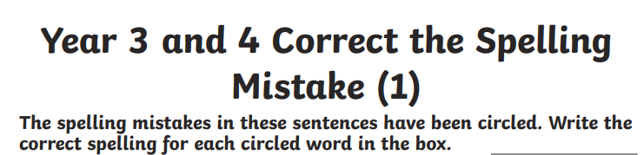

Tuesday – Complete the Year 3 spelling words wordsearch.

Wednesday – Use the words from yesterday’s word search to write a sentence. You need to learn how to spell them so can use the look, cover, write, check approach.

Thursday – Watch the following clip and complete the game/quiz. https://www.bbc.co.uk/bitesize/topics/zwwp8mn/articles/z37xrwx
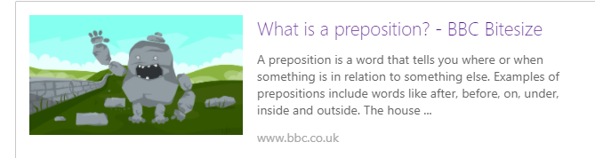

Friday – Watch the following clip and complete the game/quiz.
https://www.bbc.co.uk/bitesize/topics/zwwp8mn/articles/zw38srd

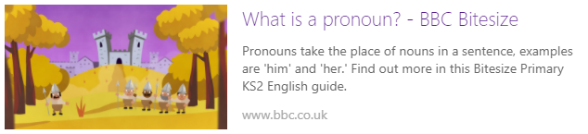

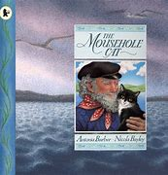
Weekly Writing Tasks

ALL OF THE INFORMATION BELOW ABOUT ‘THE MOUSEHOLE CAT’ IS ALSO AVAILABLE ON THE ATTACHED POWERPOINT

The Mousehole Cat Home Learning

Monday

Look at the picture of the boat being tossed about at sea within the paws of the Storm-Cat. You may also find it useful to re-read the story from ‘Now she lifted her head and sang like a siren, joining her call with the cry of the Great Storm-Cat’ up to ‘Then the Great Storm-Cat began to purr with Mowzer, and as the soft sound grew, the winds waned and the waves weakened’ on the PDF or listen to this part 7.20 - 10.46 on the YouTube clip.
https://www.youtube.com/watch?v=3La59tdXs2U

- Imagine that you are Mowzer the cat, on the boat in the middle of the storm. What can you hear? What can you see? How does it make you feel? How would you describe the water? The boat? The sky? The storm/Storm-Cat? When Mowzer ‘sings’ to the Storm-Cat, what might she be saying? What might she be saying to calm the storm?

- Brainstorm your ideas on paper. Try to include adventurous adjectives, verbs and adverbs. For example, rather than just writing ‘loud’ wind you might improve that with ‘howling’ wind.

Tuesday

Look again at the picture of the boat being tossed about at sea within the paws of the Storm-Cat and re-read your ideas from yesterday. In the grip of the storm Mowzer begins to ‘sing’ to the Storm-Cat and calms it, allowing Tom to catch the fish and the boat to return safely to the harbour.
You are going to use your ideas from yesterday to imagine you are Mowzer and write ‘Mowzer’s Song’, in other words, a poem from Mowzer to the Storm-Cat.
- What is she saying to the Storm-Cat about the storm and how it feels to be on the boat?
- What is she saying to calm the Storm-Cat? For example, in the book it says ‘Mowzer felt a sudden strange sadness for him. How lonely it must be, she thought, endlessly hunting the men-mice in the deeps of darkness, and never returning to the rosy glow of a red-hot range’. Does she try to comfort him? Persuade him he is not alone?

Wednesday

From whose point of view is the story told? How do you know? Do you think Tom would tell the same story as Mowzer? Today we are going to think more about the character of Tom.
Draw a small picture of Tom in the middle of your page. Then write down everything you think you know about him around your picture. If you are giving your opinions, can you explain some of your ideas by referring to the text. For example, ‘I think he ____ because in the story it says______’.

Thursday

You are going to use your ideas from yesterday to help you write in role as Tom.
Imagine that you are Tom at the very end of the story, having just returned to the harbour. Write a letter to your friend, telling them about the events that have happened and about your special cat Mowzer.
You might include paragraphs about:
- Why you decided to go fishing even though you knew it was dangerous.
- What it was like being on the boat in the storm.
- How your special cat Mowzer helped you.
- What and who you saw when you returned to the harbour that night.
- How the village celebrated and how you felt knowing you had helped everyone.
Remember to set out your writing like a letter. Check your sentences make sense and you have used full stops and capital letters. Exclamation marks and question marks used correctly would also help make your writing interesting.

Friday

We have finished our work on ‘The Mousehole Cat’! We hope you have enjoyed the story.
Today you are writing a book review of the story. We would like you to explain:
- Who are the main characters and where is the story set?
- What did you like about the story? What was your favourite part and why?
- Which are your favourite illustrations and why?
- Is there anything you did not enjoy about the story and why?
- Who would you recommend the story to and why?

Afternoon Topic work

Monday - History
Read the introduction to the Stone Age Topic.
- Complete Stone Age Task 1 – looking at tools that they might have used during this time.
- Complete Stone Age Task 2 - researching Stone Age monuments in the area.

French
Read through the French Powerpoint presentation with the names of the family members on them.
I would like you to draw your family members and label them with French words. Colour it in and present it beautifully.
Go onto Purple Mash and look at the pronunciation of the family members.

- Log on to Purple Mash
- Click on Topics
- Click on Languages
- Click on this icon
- Then click on Introducing the family

Tuesday
Science
Open the Science PowerPoint presentation – faster and slower. This will explain the effect that different surfaces have on movement. Try the investigation and tell me what you found out.

Computing
For the rest of this term in computing we are learning about online safety with the help of Kara, Winston and the SMART Crew!
Lesson 1 – Email and Virus Awareness
Watch the first part of the clip https://www.youtube.com/watch?app=desktop&v=6RdEVRpTMR4&feature=youtu.be
The Adventures of Kara, Winston and the SMART Crew - Full film - YouTube
from the beginning up to 3.33. You may want to watch the clip a couple of times.
- Why was Winston suspicious of the email straight away?
- What advice do the Smart Crew give about emails, attachments and viruses?
- Why must you never open an attachment from an unknown email address? What might happen? What should you do instead?

Wednesday

PSHE
Eat Well, Live Well with Mr Sidat – Life is all about balance
This is the first lesson in our ‘Healthy Living’ theme for the rest of this term. Click on the link below and work through the video and activities.
https://classroom.thenational.academy/lessons/life-is-all-about-balance-crwk6r

PE
PASS Dance Lesson 2
Use the PASS website to complete the Dance lesson 2 for Year 3/4. Use the link below.
https://youtu.be/iNHGGERTJEc

Thursday
Art
Think about the story of The Mousehole Cat.
- How would you describe Mowzer? What does she look like?
15 min challenge – use a pencil to draw a picture of Mowzer or your own cat if you have one.
- Now watch this video and try drawing a cat again. Pause the video as you need to whilst watching it so you can keep up.
https://www.youtube.com/watch?v=BapmtoEDcHc
How to Draw a Cat (Tabby)
Visit http://www.How2DrawAnimals.com or my channel for more animal drawing tutorials and don't forget to PAUSE the video after each step to draw at your own pace. You can request an animal in the comments section, but please be patient while I get to your request. You also have a better chance of getting your request done sooner if you're a ...
www.youtube.com
- Shade or colour your picture in carefully.
- Compare your two pictures. How are they different? Which looks more realistic?
Friday

PE
PASS Live Multi Skills Lesson 1.30 – 2.15
Please use the log in details that were sent via class dojo to log in to the live Zoom session. Please remember to read the disclaimer and policy document that was also sent out.

Music
Music Year 3/ 4 - Exploring 4 beats in a bar
https://classroom.thenational.academy/lessons/exploring-4-beats-in-a-bar-cgwk2t
You will need some headphones (or somewhere to work where you won't disturb anyone else). Click on the link above and work through the lesson on the screen.

#TheLearningProjects

