

Lunsford Primary School – Home Learning
Tuesday 5th January – Friday 8th January 2020
Year 3 – Lion Class
Weekly Maths Tasks | Reading tasks
If you have access to a computer, there is a link to the maths video. However, you can complete the sheet without watching it.  Tuesday  Spr3.1.1 - Consolidate 2 4 and 8 times-tables on Vimeo  Consolidation of the 2,4 and 8 times table sheet.  This will ease you back into maths sessions this week.  TTRockstars x 15 mins  Wednesday  Spr3.1.2 - Comparing statements on Vimeo  Comparing statements sheet.  TTRockstars x 15 mins  Thursday  Spr3.1.3 - Related calculations on Vimeo  Related Calculations sheet.  TTRockstars x 15 mins  Friday  Spr3.1.4 - Multiply 2-digits by 1-digit (no exchange) activity on Vimeo  Multiply 2 digits by 1 digit sheet.  TTRockstars x 15 mins  Go on Purple mash and complete maths games.  www.ictgames.co.uk | Tuesday  Whale Watch  Read non-fiction text about whales. Then read the questions on page 2 and see how much you can remember. You can write the answers down in full sentences.  Wednesday  Read your book for 20 mins and record in your Buster’s book club record.  Thursday  James and Giant Peach Reading comprehension sheet.  Friday  The final challenge reading comprehension sheet.
SPaG
Tuesday – SpaG activity 1
Long vowel sounds sheet super challenge.

Wednesday
Learn the following words by heart. Make up a sentence with each word in it. Use your best handwriting.
famous favourite forward fruit grammar group guide

Thursday
Try to answer the SPaG questions on the Grammar challenge cards.

Friday - SpaG activity 4
Fun with phonics super challenge: what am I? Sheet.

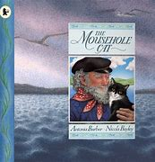
Weekly Writing Tasks

The Mousehole Cat Home Learning Planning
The Mousehole Cat read by Miss Drayton - YouTube

Tuesday
Introduce the story and look at the picture of the cover on the PowerPoint. What can you see? Make predictions about the story.
This story is a legend. A legend is a story that has some truth in it and this book is a retelling of the true story of Tom Bawcock which is commemorated every December in the village of Mousehole in Cornwall.
Look at where Mousehole is on the map and look at the pictures in the PowerPoint. Where is Mousehole? What sort of place is this? How might the geography of the area influence people’s lives? What might it be like to live there in the wintertime? Why do you think this?
Write a few paragraphs in full sentences, answering these questions.

Wednesday
Either watch the clip of the story being told OR read the PDF copy of the story up to where the storm begins.
Look at the picture of the storm arriving at the harbor wall. Look at it carefully and think about how you would describe it. What can you see? What does it remind you of? How do the fishermen feel in their boats? What words or phrases does the writer use to show the fierceness of the storm? Personification is when a writer gives something human or life-like qualities. Can you find any examples on this page?
Write a short description of the storm using interesting adjectives, verbs and adverbs. Remember full stops and capital letters. Try to extend some of your sentences using conjunctions.
(Art on Thursday – Watch the clip about shading. Then use pencils or pastels to create your own picture of a stormy sea. Think about the shapes and different shades of colours that you can see in the picture in the book)

Thursday
Finish watching the rest of the story on Youtube or read the rest of the book from the PDF. Start to draw a story map of the story (on A4 paper is fine but A3 would give you more space!), identifying the main events, characters and places. Remember your story map can be simple ‘stick’ pictures with arrows to the next main event, please do not spend time on detailed drawing and colouring. Instead, try to focus on remembering the important key events and annotating with the speech and thought bubbles for the characters. The aim of the story map is to help you remember and re-tell the story in your own words.
This will be continued tomorrow.

Friday
Re-read your story map from yesterday and then complete it today. Once you have completed your story map, re-tell the story to a grown up using your story map to help you.


Afternoon Topic work

Tuesday
Science
This term we are studying forces. Read the Science Power Point. This explains what a force is and gives example.

- Complete the push and pull home learning task.
- Complete the magnetic materials game.

ICT
- TTRockstars
- Go onto the Purple mash website and try the Logo programmes. You need to try and make the characters move around the screen using the different commands. Try any of these below.
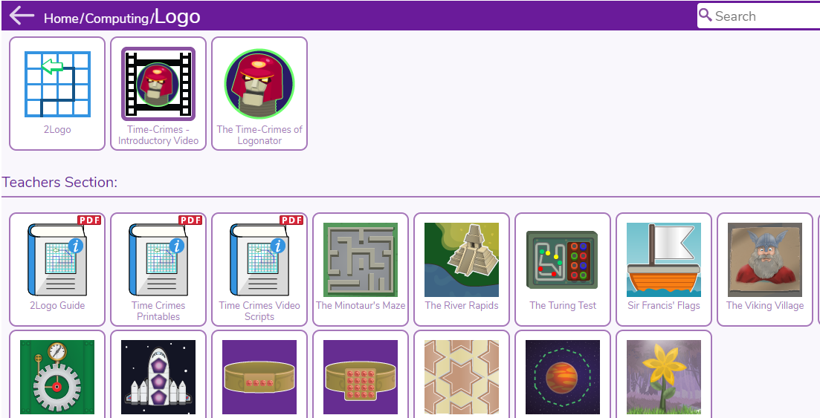

Wednesday

Forest school – In school we will be going out in the Forest school area so you might want to go outside and do some of the forest school activities that we do.
Here are some examples:
- Collect sticks, leaves, berries and create a nature picture.
- Climb a tree with an adult supporting you.
- Make a den outside, can you make it waterproof?
- Dig for worms. Can you find other insects?

PSHE
Think about the new year. It is now 2021 and a whole year to reach a new goal or overcome a challenge. What would you like to achieve this year? Why? What challenges might you have to overcome to get there? It could be something that you would like to achieve when you come back to school or a more personal challenge.
Write it inside the star. Colour it in afterwards.

Thursday
Art
Watch the clip about shading Shading - National 4 Art and Design - BBC Bitesize
Have a go at the different shading techniques for shading using the attached sheets.
Shading circles activity sheet

Link to The Mousehole cat book – can you sketch a stormy sea picture. Use pencils or what you have at home. Think about the shapes and tones that you can create.

Friday
Music
Music Year 3/ 4 - Pulse and Metre
All you will need are headphones (or somewhere to work where you won't disturb anyone else), pencil & paper and your hands. Work through the lesson below.
Week 1 lesson
https://classroom.thenational.academy/lessons/understanding-pulse-and-rhythm-chj3cr
Understanding pulse and rhythm
In this lesson, we are going to find the pulse and explore rhythm.
classroom.thenational.academy

PE – Dance
Use the PASS website to complete the Dance lesson. Use the link below.
https://youtu.be/iNHGGERTJEc

#TheLearningProjects

