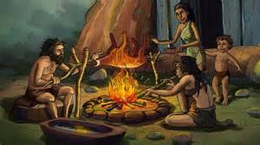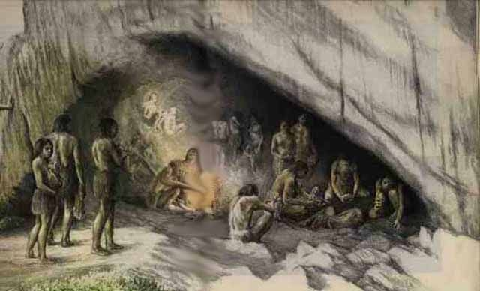Introduction to new topic: The Stone Ae

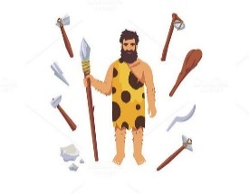The Stone Age ( and Bronze Age too)

In our History Topic we will be study the Stone and Bronze Ages in Britain. This was a time between roughly ten thousand and three thousand years ago - before people lived in houses, village or towns. The people had to hunt animals to survive, as they hadn’t yet learned how to farm crops for food, or how to raise and keep animals for food.

They lived in caves when they could, but had to more around anyway in order to follow the animals they needed to hunt for food. It must have been cold and bleak, especially in winter! I wonder what sort of clothes would they have had, what sort of shelter would they live in if there was no free cave to live in?

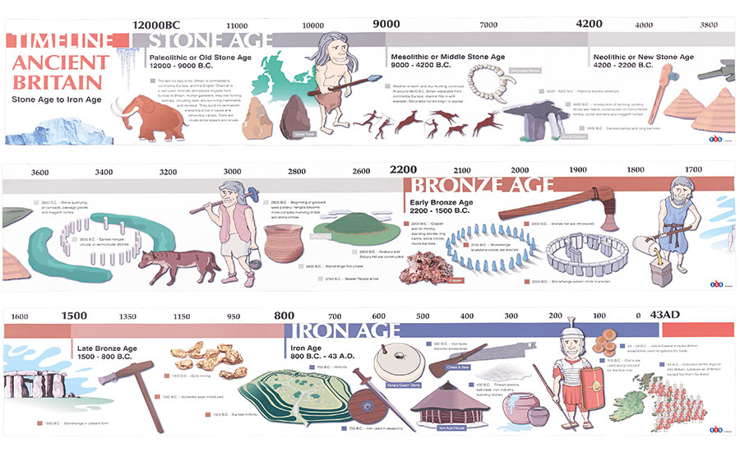These are the sort of things we will be thinking about during this topic, as well as considering whether YOU would have liked to live in this time. We only know about what life was like in those times from what the Stone Age people left behind, as oneproblem was that no one during those times could write anything down. Imagine that, the grown-ups couldn’t read or write, and you can!Image result for Stone Age Britain Lady Bird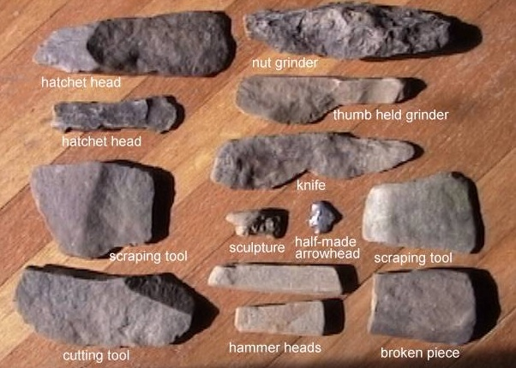Amazon.com : Laeacco Cartoon Circus Theme Backdrop 5x3ft Vinyl Circus Text  Board Clowns Tents Colorful Buntings Pink Yellow Balloons Blue Radial  Stripes Background Baby Birthday Party Banner Child Baby Shoot : Camera