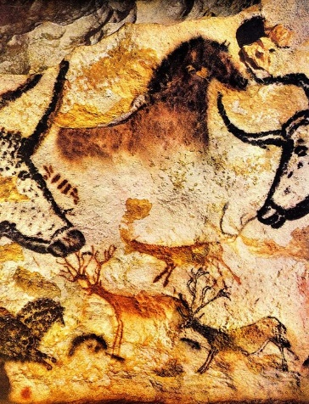

Lesson3: Stone Age cave painting

What to do in your spare time if you’re living in a cave 30,000 years ago? Remember you have no electricity, ipads, phones, or computers and no toyshops! So no television, music, minecraft, no books, the list goes on. So, what do you do? Well, maybe you decide the time is right to do some painting on the walls of your cave…

Try and find out a little more from these websites so that you can answer the questions below:

<https://www.twinkl.co.uk/homework-help/history-homework-help/the-stone-age-facts-for-kids/what-are-cave-paintings>.

Watch this power point on the website.

* How old are the oldest cave paintings still in existence?
* Where are they found?
* What sort of things were painted, animals, plants, people themselves?
* How did the stone age people create the paint in the first place ?

2. Once you have done your research have a go at creating your own cave art! Follow these ideas

1. Get a plain piece of A4 size paper and gently tear off tiny strips of the straight edges all the way round, so your paper begins to look old.( Have a trial go first, children often tear too much away, and the finished piece of paper might be too small!)
2. Stain your paper brown by using a wet tea bag like a sponge, or use diluted cold coffee with a paint brush. Try not to wet your page too much!
3. Leave your paper to dry.
4. Use coloured chalks, coloured pencils or paint to create your pictures. You may only use these colours though! Red, orange, yellow brown, black and white.
5. Have a practice of your cave art designs first, on ordinary paper, and once you’re happy with them draw them onto your stained brown paper.

Use thick black lines first to create your outlines, then colour them in.

Here are some examples of children’s finished work. Good luck!

