Date
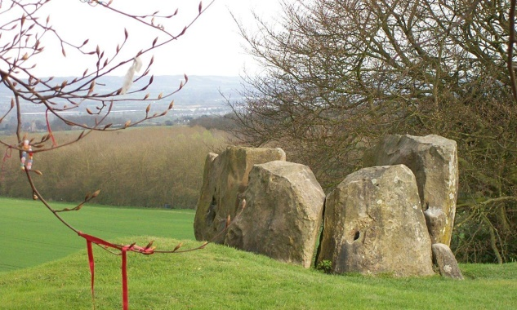
Stone Age Home learning
(Task 2 )
We have amazing examples of Stone Age monuments in the Medway Valley – a few miles from our school!

Can you find out the names or locations of these monuments?
Lets go on a
Paragraph Hunt!

I found out these names
Name of monument Where?

I think they were used for ………………………………………………………………………..

……………………………………………………………………………………………………………………
CONTENTS

