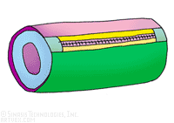 |  | 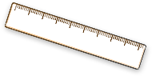 | 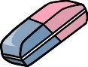 | 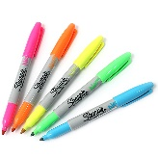 | 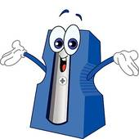
Pencil case | Coloured pencils | Ruler | Rubber | Pack of pens | Sharpener
£5.95 | £3.20 | £1.15 | 45p | £4.00 | 36p

Challenge: Can you write your answers in both £ and pence?
- James buys a rubber and a sharpener. He pays with a £1.00 coin. How much change does he receive?
- Ellen buys a ruler and a rubber. She pays with a £2.00 coin. How much change is she given?
- Tom has £5.00. He buys a pack of pens and a rubber. How much money does he have left over?
- Sophie buys a packet of coloured pencils and a sharpener. She pays with a £5.00 note. How much change is she given?
- Joe buys a packet of coloured pencils and a ruler. He pays with a £5.00 note. How much change is he given?
- Amy has saved up £10.00. She buys a pencil case and a ruler. How much money does she have left over?
- Amy wants to buy a packet of coloured pencils with her change. How much more money will she need?

Challenge:
- Can you write and solve your own word problem, involving adding together the cost of two items and finding change?

