**Monday:**

**Maths:**

White Rose Maths Year 5, Week 11

[Year 5 | White Rose Maths](https://whiterosemaths.com/homelearning/year-5/) – Perimeter and Area

Monday – Measure perimeter

**English:**

If we had all been in School we were going to be doing a lot of work and fun activities based around the book ‘The Polar Express’ by Chris Van Allsburg.

* If you go onto YouTube you can listen to the whole book being read to you (17 mins).
* Ideally get someone to read the passage below to you, while you shut your eyes and imagine the scene Otherwise carefully read the passage.

***It was the night before Christmas and all was still. Downstairs I heard the noise of our grandfather clock ticking. Every second meant it was closer to Christmas day. I lay in bed motionless. I wondered if Father Christmas was outside? What would he do if he caught me? I slowly crept out of my bed and carefully opened my bedroom window. I looked down onto my street.***

[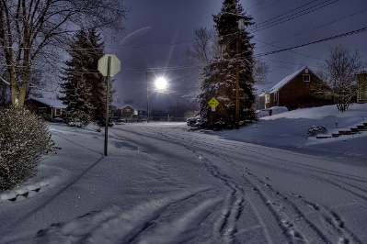](http://www.google.co.uk/url?sa=i&rct=j&q=&esrc=s&frm=1&source=images&cd=&cad=rja&docid=6uLXJiInDHUSlM&tbnid=QTDwUWr1zqcUMM:&ved=0CAUQjRw&url=http://www.flickr.com/photos/bmhgallery/4266617113/&ei=9SZyUtmZDuTz0gXi6YGwAQ&psig=AFQjCNEXHq7AP4FJv1ruvEXPUFZ88tZENg&ust=1383298979958974)

Open your eyes and look at this picture of a calm street.

Pretend to step into the picture.

* Using all your five senses (taste, touch, smell, hear and sight) make notes about what you would experience if you were actually in this street. Include lots of similes and metaphors.

Simile – The snow was **like** a white carpet.

Metaphor – The snow **was** a white blanket.

You may use your imagination to describe sounds in the distance e.g. church bells or perhaps cats fighting.

If possible discuss the picture and your ideas with an adult.

If you have printed this page you can cut the picture out and stick it on a clean page and make your notes around the edge using pencil ruled labelling lines. Otherwise make bullets points under the five senses headings e.g.

**Taste**



**Sight**



**Be sure to use a thesaurus and dictionary.**

**The presentation of your work is important – make sure you are proud of it.**

**Spellings**:

* Please spend at least 15 minutes learning the yr5/6 spellings (or other personalised list). Over this last term you should have learnt the first two columns so if necessary you can revise these and then move onto columns 3 and 4.
* Include each word in a correctly spelled and punctuated sentence.

**Reading:**

* Please read for at least twenty minutes.

**Science (Monday)**:

* During the last two science lessons you were independently researching the life cycles of amphibians and insects. If necessary remind yourselves of these facts.
* Write a description of the similarities and differences of these two life cycles. You may wish to do this by splitting a page in half length ways and label one amphibians and the other insects and then compare each stage of the life cycles.

**TT Rockstars:**

10 minutes, including the ‘Daily Sound Check’.

**Tuesday:**

**Maths:**

White Rose Maths Year 5, Week 11

[Year 5 | White Rose Maths](https://whiterosemaths.com/homelearning/year-5/) – Perimeter and Area

Tuesday – Perimeter on a grid

**English:**

* Revise your knowledge of similes and metaphors by looking at this bbc bitesize site

[**https://www.bbc.co.uk/bitesize/topics/zfkk7ty/articles/z9tkxfr**](https://www.bbc.co.uk/bitesize/topics/zfkk7ty/articles/z9tkxfr)

* Listen to the book again make a list of all the metaphors and similes you hear.
* Listen as the book is read stop when the Polar Express arrives outside the boy’s bedroom window 3.08 mins in the calm street.
* In rough, rite a **detailed** description of how you imagine the calm street (yesterday’s work) is transformed when the Polar Express arrives. Some description is mentioned in the book. Please write in full sentences, use paragraphs and appropriate punctuation. You may like to “magpie” some of the simile and metaphor ideas from the story?
* When you are happy with your work please copy it (with any changes you feel would improve it) onto lined paper.

**You do not describe getting on the train.**

Please check your work carefully for spelling mistakes, correct punctuation and for sense.

Your completed work should be at least a page in length.

* Spellings

Spend 15 minutes continuing to lean your Yr5/ spellings (or other personalised list)

**Reading:**

* Please read for at least twenty minutes.

**Science:**

* In the same way as you found out about the life cycles of amphibians and insects now find out about the life cycle of birds.

**TT Rockstars:**

10 minutes, including the ‘Daily Sound Check’.

**Wednesday:**

**Maths:**

White Rose Maths Year 5, Week 11

[Year 5 | White Rose Maths](https://whiterosemaths.com/homelearning/year-5/) – Perimeter and Area

Wednesday –Perimeter of rectangles

**English:**

* Listen once more to the story. I know you’ve heard it before but if we were in class we would be looking at the actual text in detail – this is the next best option.

This writing task is based upon the part of the story when the train has arrived at The North Pole and the boy meets Santa Claus.

The boy can ask Santa Claus for anything in the world.

* The boy chooses a simple, meaningful gift over a fancy gift that is meaningless. Think of someone you love very much. What kind of gift could you give that person that would mean as much as the boy's bell? It doesn't have to be a real object.
* Plan and edit your work in rough and then copy it onto lined paper. Check for sense, accuracy and good presentation.

**Reading**

* Please read for at least twenty minutes. Try and read to an adult for some of this time.

**PE:**

Choose a Joe Wicks (or your favourite online exercises!) workout to do indoors or out in the garden!

**TT Rockstars:**

10 minutes, including the ‘Daily Sound Check’.

**Thursday:**

**Maths:**

White Rose Maths Year 5, Week 11

[Year 5 | White Rose Maths](https://whiterosemaths.com/homelearning/year-5/) – Perimeter and Area

Thursday – Perimeter of rectilinear shapes

**English: Polar Express**

To create interesting sentences, in 4 stages:

1) Start with a noun

2) Make into expanded noun phrase,

3) Add a verb to make into a sentence,

4) Improve by using a fronted adverbial phrase, a simile, a metaphor, parentheses (brackets) or an adverb.

**Example:**

Word: train (noun)

Phrase: the handsome, black train (expanded noun phrase)

Sentence: The handsome black train set off in a cloud of smoke. (adding verb)

Better: Slowly but surely, the handsome black train set off in a cloud of smoke. (adding a fronted adverbial phrase)

Try your own for the following nouns:

Conductor, forest, bell, elves and one of your choice!

Write these in a margin first to help you:

Word:

Phrase:

Sentence:

Better

**Topic - Russia**

We have spent two sessions in the ICT suite, researching our own facts on a topic each child has chosen about Russia – e.g. Russian wildlife, food and drink, sports, Faberge Eggs, famous people, famous people, Moscow, Russian dolls etc., or just generic facts about Russia.

Unfortunately, you will not have your jotter at home, where you have recorded your facts, but you could spend an hour this week and an hour next week, researching and producing an amazing double page information page. Look at these below for examples of how to set out your pages:

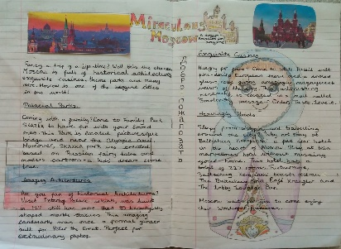 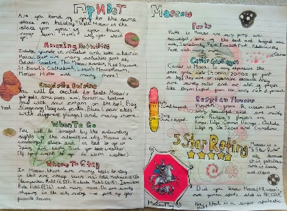

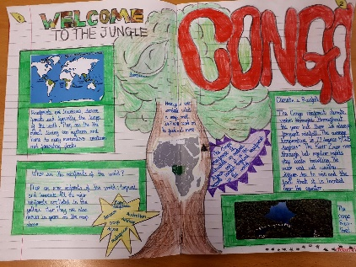 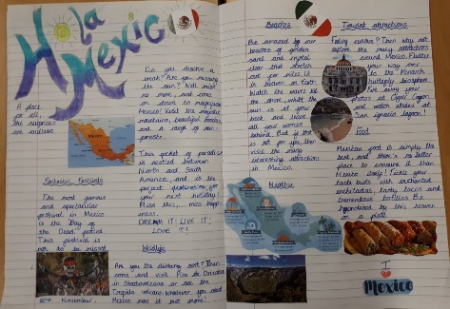

**Spellings:**

Choose 10 words from the Year 5/6 list that you find tricky and learn them. Put them in to a sentence. Could you be clever, and start each sentence with a fronted adverbial phrase?

e.g.

All of a sudden, the **ancient** statue began to move.

**TT Rockstars:**

10 minutes, including the ‘Daily Sound Check’.

**Friday:**

**Maths:**

White Rose Maths Year 5, Week 11

[Year 5 | White Rose Maths](https://whiterosemaths.com/homelearning/year-5/) – Perimeter and Area

Friday – Calculate perimeter

**English:**

Russia Reading Comprehension – don’t print the whole thing! It is differentiated into 3 levels, one star being the easiest and three stars being the hardest.

**Topic:**

Carry on your information pages on your chosen topic on Russia.

**PE:**

Choose a Joe Wicks (or your favourite online exercises!) workout to do indoors or out in the garden!

**TT Rockstars:**

10 minutes, including the ‘Daily Sound Check’.