**Monday:**

**Maths:**

White Rose Maths Year 5, Week 12

[Year 5 | White Rose Maths](https://whiterosemaths.com/homelearning/year-5/) – Perimeter and Area

Monday – Counting Squares

**English:**

I’m sure you know the story by now. Today I’d like to imagine that you have received a special gift from Father Christmas.

The boy's bell is magic-only he can hear it. Imagine you find or are given a magic_________ that only you can _________ (you fill in the blanks). Describe how this object changes your life.

* As we’re not at school you can’t share your ideas with the class so instead discuss your ideas with an adult.
* Use your imagination.
* Think outside the box- be original.
* Write your work in rough first. Don’t worry about tidiness and spelling at this stage just get your ideas down on paper.
* Ensure your work is correctly punctuated, the spelling is accurate and you have used adventurous vocabulary.
* When you are happy that you have edited/ purple penned your work, copy it (with any further improvements) on to lined paper and place it in your comprehension folder.

**Reading:**

Please read for at least half an hour. Try and read to an adult for some of this time.

**Spellings**:

* Please spend at least 15 minutes learning the yr5/6 spellings (or other personalised list). Over this last term you should have learnt the first two columns so if necessary you can revise these and then move onto columns 3 and 4.
* Include each word in a correctly spelled and punctuated sentence.

**Science:**

Last week you researched the life cycle of birds. This week if possible I’d like you to look inside a chicken egg. We all eat eggs but have you ever really looked at what’s inside.

* Carefully crack an egg into a clean, white or light coloured bowl. Be careful not to break the yolk.
* Using the attached worksheet label the diagram. Do some extra research about what each part of the egg does
* You should end up with a **detailed labelled diagram**. Draw your labelling lines with a pencil and ruler.

**Diagram of the inside of an Egg**

Using the links below and any other resources try and label this diagram.

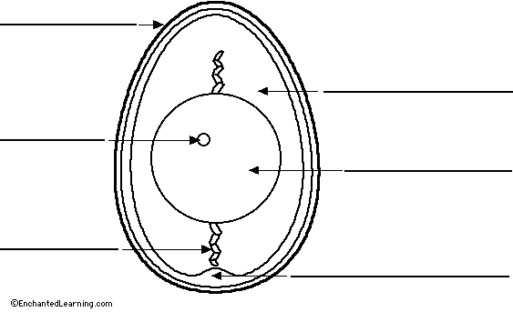

<https://www.youtube.com/watch?v=QDv0Nnyb1WA>

<https://www.youtube.com/watch?v=APS8nVaO26k>

<https://study.com/academy/lesson/egg-facts-lesson-for-kids.html>

<https://kids.britannica.com/students/article/egg/274131>

<https://www.saudereggs.com/blog/the-different-parts-of-an-egg/>

<http://www.vtaide.com/png/egg.htm>

On a separate piece of paper write a short explanation about each part of the egg.

Your work should be accurate- make sure you copy the parts of the egg carefully and well presented.

This work will be stuck into your science book when we return to school.

**Tuesday:**

**Maths:**

White Rose Maths Year 5, Week 12

[Year 5 | White Rose Maths](https://whiterosemaths.com/homelearning/year-5/) – Perimeter and Area

Tuesday – Area of Rectangles

**English:**

We have complete lots of persuasive writing tasks in class.

Today I would like you to write a persuasive letter to Father Christmas. A Persuasive Writing checklist will be sent separately.

You need to show both sides of the situation.

You could start your letter along the lines of:

Dear Santa,

You may have seen me kick me brother. However, I did help him with his homework last week so I really think I deserve……

You’ll need to include reasons for Santa giving you presents and also anticipate reasons why he might not think you deserve them! Don’t forget little misdemeanours you may have committed at school – he will know!

Please check your work carefully for spelling mistakes, correct punctuation and for sense.

Your completed work should be at least a page in length.

**Reading:**

* Please read for at least twenty minutes.

**Christmas Crafts:**

Another eggy task that you may like to try.

Christmas Tree Decorations:

* Ask an adult if you can have an egg.
* Blow the egg and rinse it thoroughly under running water.
* When it is dry try painting and decorating it like we did when we made our Faberge eggs in school.
* Do not rush each stage let the paint dry before you decorate.
* If you haven’t any gems, ribbons, beads or even edible cake decorations then you may like to cut out small pictures from Christmas paper or magazines and stick them carefully to the egg.
* You could seal the surface with clear nail varnish- **ask mum.**

**TT Rockstars:**

10 minutes, including the ‘Daily Sound Check’.

**Wednesday:**

**Maths:**

White Rose Maths Year 5, Week 12

[Year 5 | White Rose Maths](https://whiterosemaths.com/homelearning/year-5/) – Perimeter and Area

Wednesday – Area of compound shapes

**English:**

* Listen once more to the story. I know you’ve heard it before but if we were in class we would be looking at the actual text in detail.

For the next two days we would like you to retell the story of The Polar Express in your own words.

This will involve a day of planning followed by a day of editing and improvement before copying it on to paper for your folder.

* Re-tell the story of The Polar Express. Make sure your story has a beginning, middle and end. You will need to describe the setting and introduce the characters – plenty of opportunities to use lots of description using adjectives! Make the middle exciting using adverbs and adjectives. Perhaps even a fronted adverbial phrase or two!

**Reading**

* Please read for at least twenty minutes. Try and read to an adult for some of this time.

**PE:**

Choose a Joe Wicks (or your favourite online exercises!) workout to do indoors or out in the garden!

**TT Rockstars:**

10 minutes, including the ‘Daily Sound Check’.

**Christmas Crafts:**

Why don’t you try a Christmas craft or get creative in the kitchen? You could make peppermint cream polar bears or make some lovely, warming soup suitable for a journey on the Polar Express! Or something else creative – it’s up to you! These two recipes are attached.

Or you could try making these lovely ‘mini yarn hats’ – all you need is some wool and a toilet roll tube.

[Mini Yarn Hats Ornaments - DIY Christmas Ornaments - Easy Peasy and Fun](https://www.easypeasyandfun.com/mini-yarn-hats-ornaments/)

Or choose your own, depending what you have in the house. Please make sure an adult is supervising if you are using a knife or the oven!

**Thursday:**

**Maths:**

White Rose Maths Year 5, Week 12

[Year 5 | White Rose Maths](https://whiterosemaths.com/homelearning/year-5/) – Perimeter and Area

Thursday – Area of irregular shapes

**English: Polar Express**

Edit with ‘Purple pen’ (it can of course be any colour if you don’t have a purple pen!) Edit and improve your story from yesterday! Re-read your story. Can you use a dictionary to check any spellings you are unsure of? Or replace some ordinary words with more exciting words, using a thesaurus?

Write up a fabulous Year 5-quality story (probably more than a page or two of the narrow lines), in your neatest handwriting, as if it were for display!

**Topic - Russia**

Last week, you recapped some of your facts about Russia. Today, we will write up our fabulous information pages. Each one will be unique, and I can’t wait to see your lovely pages with some bright and colourful pictures and designs to go with your facts!

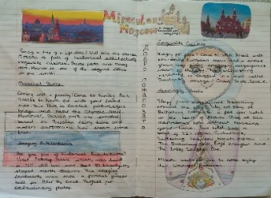 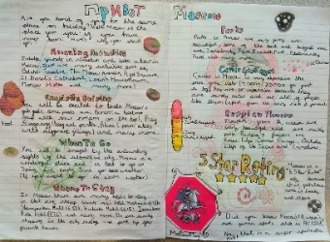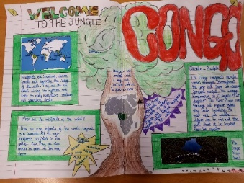 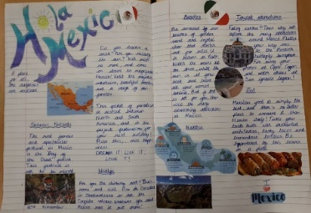

Well done on completing all of your home learning! Wishing you and your families a wonderful and well-deserved Christmas break. Keep safe and well and we can’t wait to see you in January.

Merry Christmas!

Mrs Abbott, Mrs Davies, Mr Murray and Mrs Hull

